***Title (TNR Italic, Font 22, Body Centred)***

(Author’s Details) Example given Bellow

A. B. Sharma*1, C.D. Warma2

*1Department of Mechanical Engineering,

2Department of Electronics and Telecommunication Engineering,

Sinhgad Institute of Technology, Lonavala,

Tal: xxx, Dist: xxxx, State. Pin xxxxxx, India

Tel: +91-xxxxxxxxxx, Fax: +91-xxxx-xxxxx

*Corresponding Author: abc_efg@xxxx.com

[A-4 size, Margins: Top-3cm, Bottom- 2.5cm, Left- 2.5cm, Right- 2cm

Single Column format]

***Abstract*** – Maximum 250 words, TNR, Font 12, Single space, Justified.

*Keywords – Maximum 5, TNR, Italic, Font 12, Single space, Justified.*

**1. HEADING( UPPERCASE, Bold TNR, Alignment Left,Font 12)**

Main Body (TNR, Font 12, Justified, Single space, Paragraph single tab)

***1.1 Subheading (First letter capital, Bold TNR, Italic, Font 12, Alignment Left)***

*1.1.1 Subheading (First letter capital, TNR, Italic, Font 12, Alignment Left)*

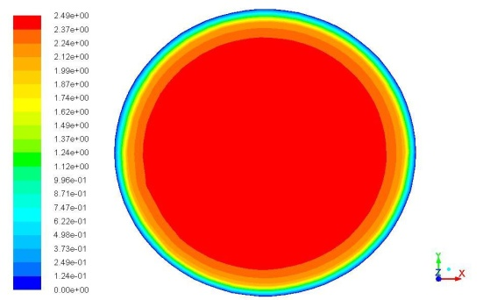

Figure 1: Name of the figure (TNR, Font 10, Body Centered)

Table I: Name of Table (TNR, Font 10, Body Centered)

|  |  |  |  |
| --- | --- | --- | --- |
| **Velocity**  **(m/s)** | **Metered Flow**  **(mᶾ/hr)** | **Percentage Error** | **Reynolds Number** |
| 0.50 | 14.397 | 0.530 | 56179.77 |
| 1.06 | 30.455 | 0.737 | 119101.12 |
| 1.61 | 45.516 | -0.450 | 181685.39 |
| 1.83 | 52.123 | 0.290 | 206632.63 |
| 2.47 | 70.439 | 0.609 | 277528.08 |

**REFERENCES**

(TNR, Font 12, Justified, Single space)

[x] Author’s Name, “Title of the Paper”, Journal Name, Volume (Issue), Year of publication: Page numbers.

Example

1. Repinsek M. C., Liu S. H., Mernik L., “A note on teaching–learning based optimization algorithm”, Journal of Information Sciences, Vol. 21 (Issue 4), 2012:79–93.